SQL Commands | DDL, DQL, DML, DCL and TCL Commands

SQL commands are fundamental building blocks used to perform given operations on database. The operations include queries of data. creating a table, adding data to tables, dropping the table, modifying the table and set permission for users.
SQL Commands are mainly categorized into five categories:
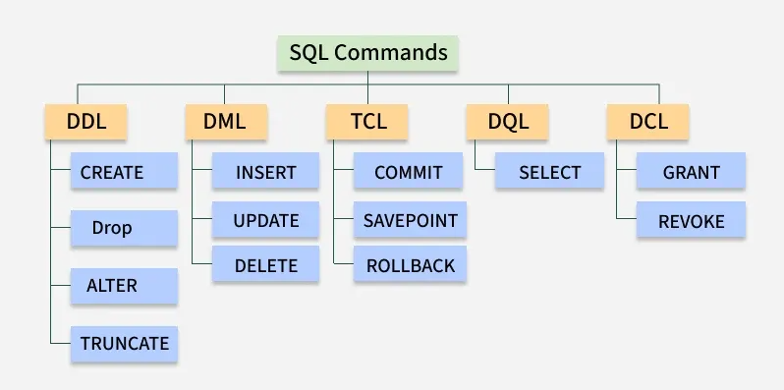

1. DDL - Data Definition Language
DDL (Data Definition Language) consists of SQL commands that can be used for defining, altering and deleting database structures such as tables, indexes and schemas. It simply deals with descriptions of the database schema and is used to create and modify the structure of database objects in the database

Command | Description | Syntax
CREATE | Create database or its objects (table, index, function, views, store procedure and triggers) | CREATE TABLE table_name (column1 data_type, column2 data_type, ...);
DROP | Delete objects from the database | DROP TABLE table_name;
ALTER | Alter the structure of the database | ALTER TABLE table_name ADD COLUMN column_name data_type;
TRUNCATE | Remove all records from a table, including all spaces allocated for the records are removed | TRUNCATE TABLE table_name;
COMMENT | Add comments to the data dictionary | COMMENT ON TABLE table_name IS 'comment_text';
RENAME | Rename an object existing in the database | RENAME TABLE old_table_name TO new_table_name;

SQL CREATE TABLE

The CREATE TABLE statement in SQL is used to define a new table in a database. It specifies the table name, column names, and their data types. This command lays the foundation for storing and organizing data.
Syntax:
CREATE table table_name
(
Column1 datatype (size),
column2 datatype (size),
.
.
columnN datatype(size)
);
- table_name: The name you assign to the new table.
- column1, column2, ... : The names of the columns in the table.
- datatype(size): Defines the data type and size of each column.

Example: Create a Customer Table
Let’s walk through a practical example where we create a Customer table that stores customer data. We will define various columns such as CustomerID, CustomerName, Country, Age, and Phone with appropriate data types and constraints.
Query:
CREATE TABLE Customer(
CustomerID INT PRIMARY KEY,
FirstName VARCHAR(50),
LastName VARCHAR(50),
Country VARCHAR(50),
Age INT CHECK (Age >= 0 AND Age <= 99),
Phone int(10)
);
Output:

Explanation:
- CustomerID is an integer and serves as the PRIMARY KEY, ensuring each record is unique.
- FirstName, LastName, and Country are VARCHAR fields to store variable-length text.
- Age has a CHECK constraint, ensuring it’s within the range of 0 to 99.
- Phone is an integer field, although in real scenarios, a VARCHAR would often be used for storing phone numbers to allow for leading zeros and formatting.

Inserting Data into the Table
After creating the table, you can use INSERT INTO command to add data into it. Here is how to add some sample records into the Customer table:
INSERT INTO Customer (CustomerID, FirstName, LastName, Country, Age, Phone)
VALUES
(1, 'Luca', 'Bianchi', 'Italy', 23, 'xxxxxxxxxx'),
(2, 'Aiko', 'Tanaka', 'Japan', 21, 'xxxxxxxxxx'),
(3, 'Carlos', 'Gomez', 'Spain', 24, 'xxxxxxxxxx'),
(4, 'Sofia', 'Müller', 'Germany', 22, 'xxxxxxxxxx'),
(5, 'Ethan', 'Johnson', 'USA', 25, 'xxxxxxxxxx');
Output:
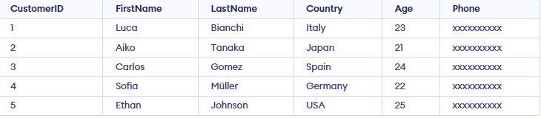

Note: If you are working with a large amount of data, consider using bulk inserts or importing data from external files to optimize performance.

Create Table from Existing Table
We can also create a new table based on the structure (and optionally the data) of an existing table. The CREATE TABLE AS SELECT command allows us to duplicate an entire table or select specific columns to form a new one. The following query creates a new table called SubTable that contains CustomerID and CustomerName from the existing Customer table.
Syntax:
CREATE TABLE new_table_name AS
SELECT column1, column2, ...
FROM existing_table_name
WHERE ...;
In this example, we create a new table SubTable that contains just the CustomerID and CustomerName columns from the Customer table. This method is useful for creating backups or performing quick data migrations.
Query:
CREATE TABLE SubTable AS
SELECT CustomerID, CustomerName
FROM customer;
Output:
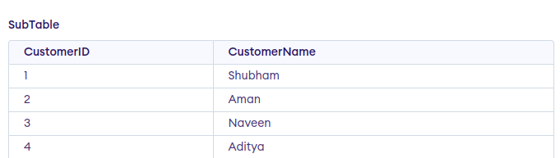
Note: We can use * instead of column name to copy whole table to another table.

Tips for Using CREATE TABLE in SQL
To ensure the smooth creation and management of your tables, keep these points in mind:
1. The CREATE TABLE statement can also define constraints like NOT NULL, UNIQUE, and DEFAULT.
2. If you attempt to create a table that already exists, SQL will throw an error. To avoid this, you can use the IF NOT EXISTS clause.
CREATE TABLE IF NOT EXISTS Customer (...);
3. Always define appropriate data types for each column (e.g., VARCHAR(50) for names and INT for IDs) to optimize performance and storage.
4. After creating a table, use the following command to view the structure of your table:
DESC table_name;
5. If you need to change the table’s structure after creation (e.g., renaming a column, adding a new column), use the ALTER TABLE statement.

DROP and TRUNCATE in SQL

The DROP and TRUNCATE commands in SQL are used to remove data from a table, but they work differently. This difference is crucial for effective database management, especially with large datasets.

SQL DROP Command
The SQL DROP command is used to permanently remove an object from a database, such as a table, database, index or view. When a table is dropped, both its data and structure are permanently removed, and the action cannot be undone without a backup.
- Permanent Removal: Deletes object and data permanently.
- Deletes Dependencies: Removes related constraints and indexes.
- Schema Deleted: Removes table structure and schema.
- No Integrity Check: Skips constraints and triggers.
Syntax:
DROP object object_name ;
- object: The type of object you want to drop (e.g., TABLE, DATABASE).
- object_name: The name of the object to be deleted.

Examples of Using the DROP Command
To understand how the DROP command works in SQL, let us explore some practical examples demonstrating its various applications.

1. DROP Table
To delete an entire table including its data and structure:
Syntax:
DROP TABLE table_name;

2. DROP database
To delete an entire database and all of its associated tables:
Syntax:
DROP DATABASE database_name;

SQL TRUNCATE Command
The TRUNCATE command is a Data Definition Language (DDL) action that removes all rows from a table but preserves the structure of the table for future use.
Although TRUNCATE is similar to the DELETE command (without the WHERE clause), it is much faster because it bypasses certain integrity constraints and locks. It was officially introduced in the SQL:2008 standard.
Syntax:
TRUNCATE TABLE table_name;
- table_name: Name of the table to be truncated.
- DATABASE name: table_name

Key Differences Between DROP and TRUNCATE

The key differences between DROP and TRUNCATE statements are explained in the following table:
DROP | TRUNCATE
Completely removes both the data and the table structure | Removes all rows but preserves the table structure
Requires recreation of the table before reusing it. | Can be used immediately after, since the table structure remains.
Non-recoverable; once dropped, the table cannot be restored (unless you have backups) | Can be rolled back if used in a transaction (if supported by the DBMS)
Does not activate triggers associated with the table | Does not activate DELETE triggers
Slower due to data and structural removal | Faster, especially for large datasets
Used when you want to completely remove a table or database | Used to quickly remove all rows from a table but keep the structure for future use

Examples of SQL DROP AND TRUNCATE Command
Let's look at some examples of the DROP and TRUNCATE statements in SQL and understand their working. Consider the given database Student_data We will perform the examples on this particular table.

ROLL_NO | NAME | ADDRESS | PHONE | AGE
1 | John | Delhi | 9415536635 | 24
2 | Michael | Gurgaon | 9414576635 | 21
3 | David | Delhi | 9815532635 | 20
4 | Robert | Noida | 9115536695 | 21
5 | Emma | Gurgaon | 8915536735 | 28
6 | Olivia | Rohtak | 7015535635 | 23

DROP Database Example
In this example, we will drop a database called student_data:
DROP DATABASE student_data;
Running this query will completely delete the student_data database, including all tables and data.

DROP Table Example
In this example, we will drop the student_details table;
DROP TABLE student_details;
This query will permanently remove the student_details table, along with all its data, from the database.

TRUNCATE Table Example
In this example, we will truncate all data from a table (e.g., student_details) while keeping the table structure as it is:
TRUNCATE TABLE Student_details;
After running the above query Student_details table will be truncated, i.e, the data will be deleted but the structure will remain in the memory for further operations.

SQL ALTER TABLE

The SQL ALTER TABLE statement is used to modify an existing table’s structure without deleting it. It helps update the design of a database as requirements change.
- Can add, delete, or modify columns in a table.
- Can also rename a table or change data types and constraints.
- Useful for adjusting database structure without losing data.
Example: First, we will create a demo SQL database and table, on which we will use the ALTER TABLE command.
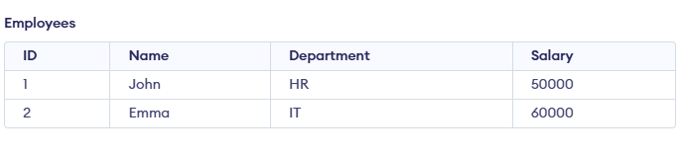
Query:
ALTER TABLE Employees RENAME TO Staff;
Output:
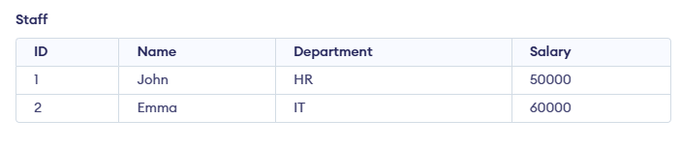
Syntax:
ALTER TABLE table_name [ADD | DROP | MODIFY] column_name datatype;
- table_name: name of the table you want to modify.
- ADD: used to add a new column.
- DROP: used to remove an existing column.
- MODIFY: used to change datatype or definition of an existing column.

Use Cases for SQL ALTER TABLE
Here are several usages of SQL ALTER TABLE

1. ADD
The ADD clause is used to add a new column to an existing table. You must specify the name of the new column and its data type.
Syntax:
ALTER TABLE table_name
ADD column_name datatype;
Query:
ALTER TABLE Staff
ADD Email VARCHAR(100);
Output:
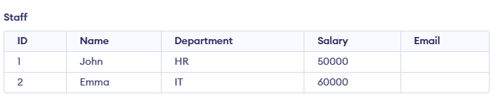
Here, we are adding a column named Email to Staff table

2. MODIFY
The MODIFY (or ALTER COLUMN in some databases like SQL Server) clause is used to modify the definition of an existing column, such as changing its data type or size.
Syntax:
ALTER TABLE table_name
MODIFY COLUMN column_name datatype;
Query:
ALTER TABLE Students
MODIFY COLUMN Address VARCHAR(100);
Here, we are modifying the column named Address datatype that is VARCHAR(100).

3. DROP
The DROP clause allows you to remove a column from a table. Be cautious when using this command as it will permanently remove the column and its data.
Syntax:
ALTER TABLE table_name
DROP COLUMN column_name;
Query:
ALTER TABLE Students
DROP COLUMN Grade;
Here, we are removing a column named Grade from Student table

4. RENAME COLUMN
We can rename an existing column using RENAME COLUMN clause. This allows you to change the name of a column while preserving its data type and content.
Syntax:
ALTER TABLE table_name
RENAME COLUMN old_name TO new_name;
Query:
ALTER TABLE Staff
RENAME COLUMN Name TO EmployeeName;
Output:
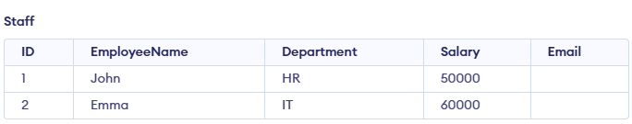
This renames the column CustomerName to FirstName in the Customer table.

5. RENAME TO
We can rename an entire table using the RENAME TO clause. This changes the name of the table while preserving its structure and data.
Syntax:
ALTER TABLE table_name
RENAME TO new_table_name;
Query:
ALTER TABLE Staff
RENAME TO Employees;
Output:
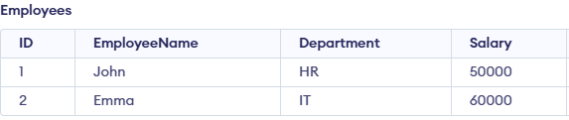
This renames the table from Customer to Clients.

SQL Comments

SQL comments are written inside SQL code to help developers understand what the code is doing. They are not executed by the database and are used to explain queries, give additional information, or make the code easier to read and maintain.-
- They help in explaining the purpose of SQL statements.
- They make the code more readable and easy to maintain.
- They allow developers to temporarily disable parts of a query for testing or debugging.

Types of SQL Comments
SQL Comments explain sections of SQL statements or prevent SQL statements from being executed. These are the three commenting methods in SQL, each with its unique use. Let's discuss these SQL comments in detail below:
There are 3 types of comments in SQL:
- Single-line comments
- Multi-line comments
- In-line comments

1. SQL Single Line Comments
Single-line comments are used to annotate a single line of SQL code. They are often employed for brief explanations or to temporarily disable lines of code without removing them. Single-line comments begin with two hyphens (--), and the comment continues until the end of the line.
Syntax:
-- single line comment
Query:
SELECT * FROM Students; -- This gets all student records
The comment explains that the query retrieves all records from the customers table.

2. SQL Multi-Line Comments
Multi-line comments are used when we need to comment out more than one line of SQL code. These comments are enclosed between /* and */ and can span multiple lines. They are typically used for longer explanations or to disable larger sections of code temporarily.
Syntax:
/* multi line comment
another comment */
Query:
SELECT *
FROM orders
WHERE YEAR(order_date) = 2022;
/* This query retrieves all orders
that were placed in the year 2022 */
The multi-line comment explains that the query retrieves all orders placed in the year 2022 from the orders table.

3. SQL In-Line Comments
In-line comments allow us to add comments within a query itself. They are typically used to provide additional information or explanations for specific parts of the query, without interrupting the flow of the SQL statement. In-line comments start with /* and end with */.
Syntax:
SELECT * FROM /* Customers; */
Query:
SELECT
customer_name, -- Name of the customer
order_date -- Date when the order was placed
FROM orders;
In-line comments explain what customer_name and order_date mean. They make the code easier to understand for others.

Important Points About SQL Comments
While SQL comments are crucial for code documentation, there are several best practices to follow when using them:
- Be Concise but Clear: Write comments that are short and easy to understand. Avoid unnecessary comments.
- Explain Complex Queries: Use comments to explain difficult queries or important business logic.
- Avoid Commenting Obvious Code: Do not comment on simple or self-explanatory SQL statements.
- Use Comments to Temporarily Disable Code: Comments can be used to comment out code for testing or debugging.
- Consistent Formatting: Use the same comment style everywhere to make the code easy to read.

SQL RENAME TABLE

Renaming a table is a common and useful operation for database administrators and developers. It is especially useful when we need to correct a naming mistake, organize our database schema, or update the table name to reflect new business requirements.
In this article, we will provide a detailed guide on how to use the SQL RENAME TABLE statement, its syntax, various examples across different databases, and the best practices to follow for successful renaming operations.

What is SQL RENAME TABLE?
In SQL, the RENAME TABLE statement is used to change the name of an existing table. This operation is typically performed when a table's name no longer reflects the data it contains, or to make the table name more descriptive or organized. Renaming a table does not affect the data or structure of the table; it only updates the table's identifier in the database schema.
The existing data, columns, constraints, indexes, and other attributes of the table remain the same. The table's references in queries, views, or stored procedures must be updated manually after renaming the table.
The syntax for renaming a table varies slightly depending on the database system we are using. Below is the general syntax for the RENAME TABLE statement.

Syntax:
RENAME TABLE old_table_name TO new_table_name;
Key terms:
- old_table_name: The current name of the table that you want to rename.
- new_table_name: The new name you want to assign to the table.

Examples of SQL RENAME TABLE in Different Database Systems
Different database systems implement table renaming in slightly different ways. Below are examples of how to use the RENAME TABLE statement across popular SQL databases such as MySQL, SQL Server, PostgreSQL, and Oracle.

Example 1: Renaming a Table in MySQL
Let’s say we have a table Customers containing customer details. Below is the SQL statement to rename the Customers table to Clients. The structure, data, and other properties of the table remain unchanged, but all references to the Customers table should now be updated to Clients.
Query:
RENAME TABLE Customers TO Clients;
Verification:
To verify that the table name has been successfully changed, we can run the following query:
SELECT * FROM Clients;
Output:
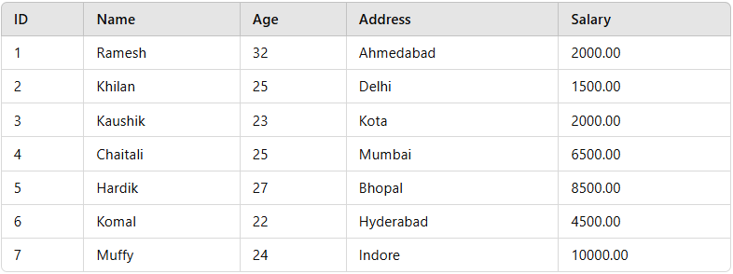Clients Table

Example 2: Renaming a Table in SQL Server
In SQL Server,renaming a table requires using the sp_rename stored procedure, as SQL Server does not support a direct RENAME TABLE statement. Instead, we use the sp_rename stored procedure to rename the table. Let’s assume we have a table called Employees and we want to rename it to Workers.
Syntax
EXEC sp_rename 'old_table_name', 'new_table_name';
Query:
EXEC sp_rename 'Employees', 'Workers';
Verification
This will display all records from the newly renamed Workers table.
SELECT * FROM Workers;
Output:
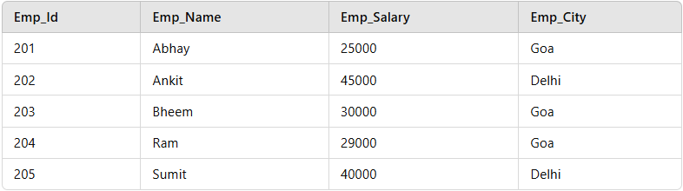Workers Table

Example 3: Renaming a Table in PostgreSQL
In PostgreSQL, we can rename a table using the ALTER TABLE statement, which is more flexible than RENAME TABLE. Here's how to rename a table called Products to Product_Inventory.
Syntax:
ALTER TABLE old_table_name RENAME TO new_table_name;
Query:
ALTER TABLE Products RENAME TO Product_Inventory;
Verification:
This query renames the table and retains the data and structure within it.
SELECT * FROM Product_Inventory;
Output:
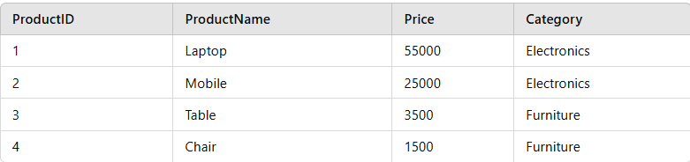Product_Inventory

Best Practices for Renaming Tables
Renaming a table is a straightforward operation, but it’s important to follow some best practices to ensure smooth database management:

1. Ensure No Active Transactions:
Renaming a table while transactions are active can cause data inconsistency or loss. If a transaction is being executed on the table being renamed, there could be errors or data being modified incorrectly. It's important to ensure that no operations, such as INSERT, UPDATE, or DELETE, are happening on the table at the time of renaming.

2. Update References:
After renaming the table, any foreign key references, views, queries, or stored procedures that referenced the old table name must be updated to reflect the new name. If these references are not updated, queries may fail, or the application may experience issues when trying to interact with the renamed table. It's essential to go through the database schema and update every reference to ensure the system works smoothly after the table rename.

3. Perform Renaming During Off-Peak Hours:
Renaming a table might lock it for a brief period, so it is best to perform this operation during off-peak hours when the system is under less load. This minimizes the impact of the temporary lock and allows for smoother operation of the database, especially for large databases or busy systems.

4. Test Changes:
After renaming a table, it is crucial to test the renamed table to ensure it functions as expected with the application and other database objects. This includes checking if queries that depend on the table are still working correctly and confirming that any updated foreign key references, views, or procedures are functioning as intended.

Limitations and Considerations

1. Dependent Objects:
When renaming a table, it's crucial to review any dependent objects such as foreign keys, views, stored procedures, and triggers. After renaming the table, these objects must be updated to reference the new table name. Failing to do so can cause errors in our database operations, as the old table name will no longer exist in the schema.

2. Database Locking:
Renaming a table may briefly lock the table, which could affect concurrent operations. During this time, other users may not be able to access or modify the table. To minimize disruptions, it’s best to perform this operation during periods of low database activity or off-peak hours. Understanding this lock duration and planning accordingly can help ensure smooth operations without affecting other tasks.

3. Permission Issues:
Renaming a table typically requires administrative privileges, so it’s important to ensure that the user performing the rename operation has sufficient rights. If you do not have the required permissions, we might encounter errors, and the table rename operation will fail. Always check our user account permissions before attempting to rename tables to avoid unnecessary interruptions.

Conclusion:
Renaming a table in SQL is a powerful operation that helps keep our database schema organized and easy to understand. Whether using the RENAME TABLE or ALTER TABLE statements, the process is simple, but it requires careful consideration of potential dependencies and permissions. By following best practices and using the appropriate syntax for our database system (MySQL, SQL Server, PostgreSQL, Oracle, etc.), we can rename tables with minimal disruption to our application and users.

2. DQL - Data Query Language
DQL is used to fetch data from the database. The main command is SELECT, which retrieves records based on the query. The output is returned as a result set (a temporary table) that can be viewed or used in applications.
Command | Description | Syntax
SELECT | It is used to retrieve data from the database | SELECT column1, column2, ...FROM table_name WHERE condition;
FROM | Indicates the table(s) from which to retrieve data. | SELECT column1  FROM table_name;
WHERE | Filters rows before any grouping or aggregation | SELECT column1  FROM table_name  WHERE condition;
GROUP BY | Groups rows that have the same values in specified columns. | SELECT column1, AVG_FUNCTION(column2)  FROM table_name  GROUP BY column1;
HAVING | Filters the results of GROUP BY | SELECT column1, AVG_FUNCTION(column2)  FROM table_name  GROUP BY column1  HAVING condition;
DISTINCT | Removes duplicate rows from the result set | SELECT DISTINCT column1, column2, ...  FROM table_name;
ORDER BY | Sorts the result set by one or more columns | SELECT column1  FROM table_name  ORDER BY column1 [ASC | DESC];
LIMIT | By default, it sorts in ascending order unless specified as DESC | SELECT * FROM table_name LIMIT number;
Note: DQL has only one command, SELECT. Other terms like FROM, WHERE, GROUP BY, HAVING, ORDER BY, DISTINCT and LIMIT are clauses of SELECT, not separate commands.

SQL SELECT Query:

The SQL SELECT statement is used to retrieve data from one or more tables and display it in a structured format of rows and columns.
- Fetches all columns using * or specific columns by name.
- Filters and sorts data using WHERE and ORDER BY.
- Supports grouping, aggregation, and table relationships using GROUP BY, HAVING, and JOIN.
Example: First, we create a demo SQL table, on which we use the SELECT query.
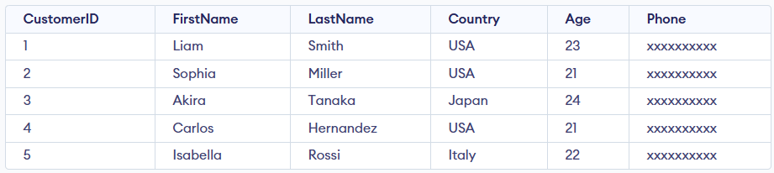Customer Table
Query:
SELECT CustomerID, FirstName FROM Customer;
Output:
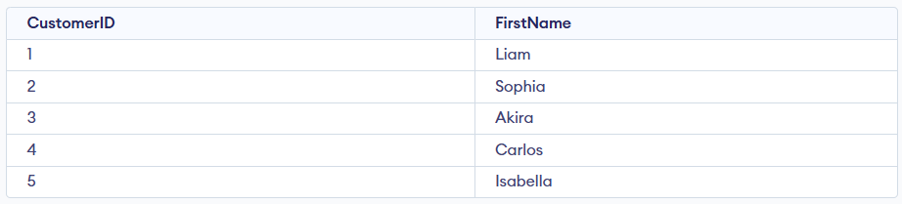
Syntax:
SELECT column1,column2.... FROM table_name;
- column1, column2: columns you want to retrieve.
- table_name: name of the table you're querying.

Working with the SELECT Statement
The SELECT statement is used to retrieve and display data from one or more tables in a structured and readable format.

Example 1: Select Specific Columns
In this example, we will demonstrate how to retrieve specific columns from the Customer table. Here we will fetch only CustomerName and LastName for each record.
Query:
SELECT FirstName, LastName
FROM Customer;
Output:
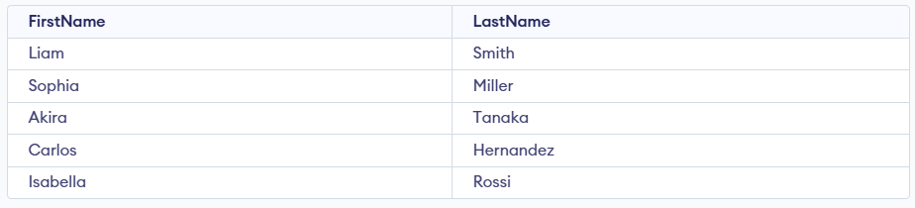

Example 2: Select All Columns
In this example, we will fetch all the fields from table Customer:
Query:
SELECT * FROM Customer;
Output:


Example 3: SELECT Statement with WHERE Clause
Suppose we want to see table values with specific conditions then WHERE Clause is used with select statement. In this example, filter customers who are 21 years old.
Query:
SELECT FirstName
FROM Customer
where Age = 21;
Output:
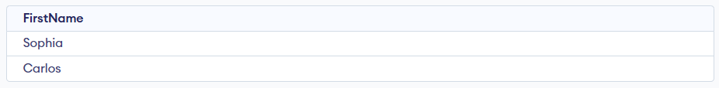

Example 4: SELECT with GROUP BY Clause
In this example, we will use SELECT statement with GROUP BY Clause to group rows and perform aggregation. Here, we will count the number of customers from each country.
Query:
SELECT Country, COUNT(*) AS customer_count
FROM Customer
GROUP BY Country;
Output:
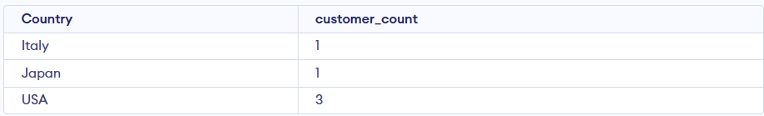

Example 5: SELECT with DISTINCT Clause
In this example, we will use DISTINCT keyword to return only unique values from a column. Here, we will fetch unique countries from the Customer table.
Query:
SELECT DISTINCT Country
FROM Customer;
Output:
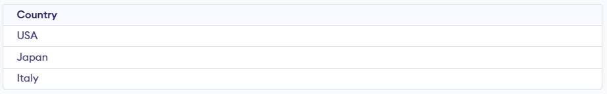

Example 6: SELECT Statement with HAVING Clause
The HAVING clause is used to filter results after applying GROUP BY. In this example, we will find countries that have 2 or more customers in the Customer table.
Query:
SELECT Country, COUNT(*) AS customer_count
FROM Customer
GROUP BY Country
HAVING COUNT(*) >= 2;
Output:

Example 7: SELECT Statement with ORDER BY clause
In this example, we will use SELECT Statement with ORDER BY clause. Here, Sort results by Age in descending order.
Query:
SELECT * FROM Customer ORDER BY Age DESC;
Output:
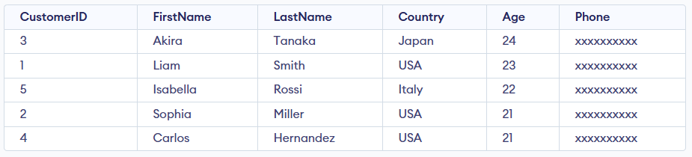

SQL - WHERE Clause:

The SQL WHERE clause filters rows based on one or more conditions, so your query returns (or modifies) only the records that match. It’s used across SELECT, UPDATE, and DELETE statements, and works with data from a single table or from multiple tables after joins
Example: First, we will create a demo SQL database and table, on which we will use the WHERE Clause command.
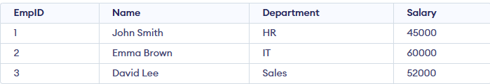
Query:
SELECT Name, Department, Salary
FROM Employees
WHERE Salary > 50000;
Output:
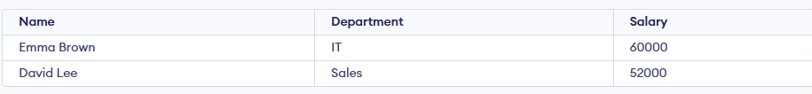
Syntax:
SELECT column1, column2
FROM table_name
WHERE column_name operator value;
- column1, column2: Columns you want to retrieve.
- table_name: Table you are querying from.
- operator: Comparison logic (e.g., =, <, >, LIKE).
- value: The value or pattern to filter against.

Examples of WHERE Clause
We will create a basic employee table structure in SQL for performing all the where clause operation.
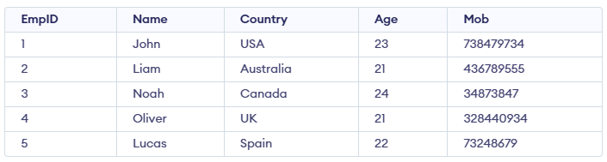

Example 1: Where Clause with Logical Operators
To fetch records of Employee with age equal to 24.
Query:
SELECT * FROM Emp1 WHERE Age=24;
Output:

Example 2: WHERE with Comparison Operators
To fetch the EmpID, Name and Country of Employees with Age greater than 21.
Query:
SELECT EmpID, Name, Country FROM Emp1 WHERE Age > 21;
Output:
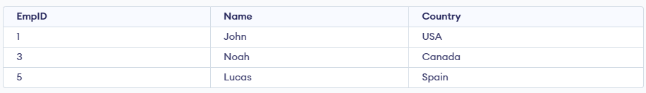

Example 3: Where Clause with BETWEEN Operator
The BETWEEN operator is used to filter records within a specified range, and it includes both the start and end values. In this example, we want to find employees whose age is between 22 and 24, including both 22 and 24.
Query:
SELECT * FROM Emp1
WHERE Age BETWEEN 22 AND 24;
Output:
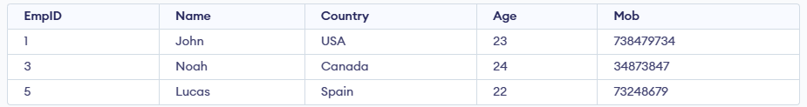

Example 4: Where Clause with LIKE Operator
It is used to fetch filtered data by searching for a particular pattern in the where clause. In this example we want to find records of Employees where Name starts with the letter. The '%'(wildcard) signifies the later characters here which can be of any length and value.
Query:
SELECT *
FROM Employee
WHERE Name LIKE 'L%';
Output:

Example 5: Where Clause with IN Operator
It is used to fetch the filtered data same as fetched by '=' operator just the difference is that here we can specify multiple values for which we can get the result set. Here we want to find the Names of Employees where Age is 21 or 23.
Query:
SELECT Name FROM Emp1 WHERE Age IN (21,23);
Output:
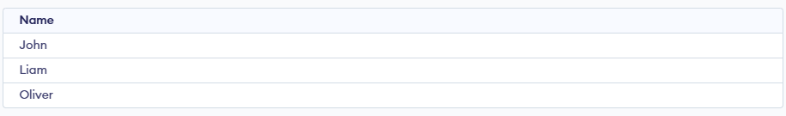

Operators Used in WHERE Clause
Operator | Description
> | Greater Than
>= | Greater than or Equal to
< | Less Than
<= | Less than or Equal to
= | Equal to
<> | Not Equal to
BETWEEN | In an inclusive Range
LIKE | Search for a pattern
IN | To specify multiple possible values for a column

SQL GROUP BY:

The SQL GROUP BY clause is used to arrange identical data into groups based on one or more columns. It is commonly used with aggregate functions like COUNT(), SUM(), AVG(), MAX(), and MIN() to perform calculations on each group of data.

Example: First, we will create a demo SQL database and table, on which we will use the GROUP BY command.
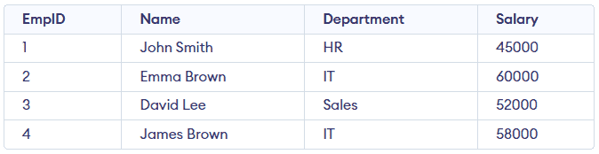Employees Table
Query:
SELECT Department, SUM(Salary) AS TotalSalary
FROM Employees
GROUP BY Department;
Output:
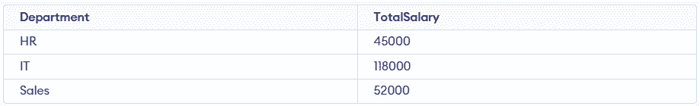
- Groups all employee records based on their department.
- Calculates and returns total salary for each department.
Syntax:
SELECT column1, aggregate_function(column2)
FROM table_name
WHERE condition
GROUP BY column1, column2;
- aggregate_function: function used for aggregation, e.g., SUM(), AVG(), COUNT().
- table_name: name of the table from which data is selected.
- condition: Optional condition to filter rows before grouping (used with WHERE).
- column1, column2: Columns on which the grouping is applied.

Working with GROUP BY
Let's assume that we have a Student table. We will insert some sample data into this table and then perform operations using GROUP BY to understand how it groups rows based on a column and aggregates data.
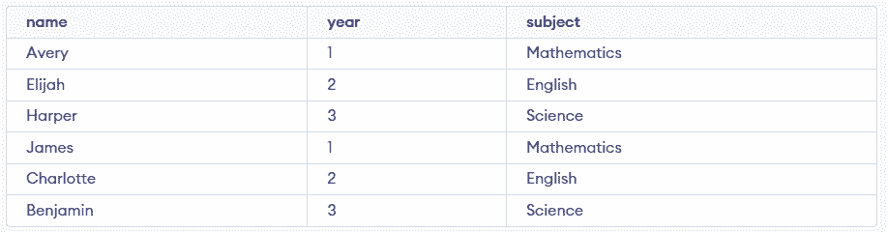Student Table

Example 1: Group By Single Column
When we group by a single column, rows with the same value in that column are combined. For example, grouping by subject shows how many students are enrolled in each subject.
Query:
SELECT subject, COUNT(*) AS Student_Count
FROM Student
GROUP BY subject;
Output:
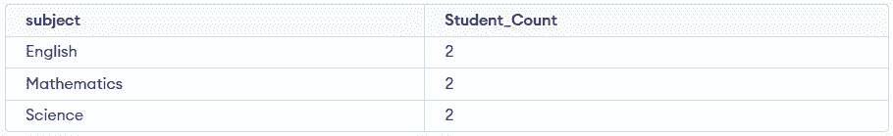
- Groups all student records by their subject.
- Counts total number of students in each subject.

Example 2: Group By Multiple Columns
Using GROUP BY with multiple columns groups rows that share the same values in those columns. For example, grouping by subject and year will combine rows with the same subject–year pair and we can count how many students fall into each group.
Query:
SELECT subject, year, COUNT(*)
FROM Student
GROUP BY subject, year;
Output:
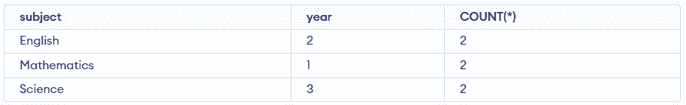
- Students with the same subject and year are grouped together.
- Since each subject and year pair occurs twice, the count is 2 for every group.

HAVING Clause in GROUP BY Clause
HAVING clause is used to filter results after grouping, especially when working with aggregate functions like SUM(), COUNT() or AVG(). Unlike WHERE, it applies conditions on grouped data.
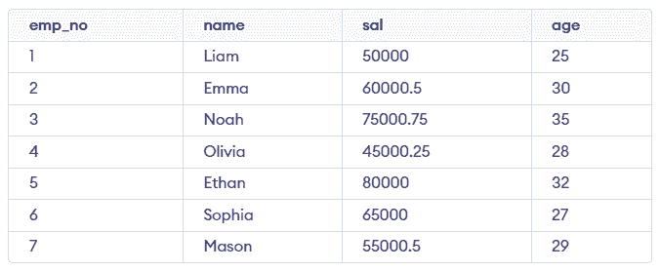Employees Table

Example 1: Filter by Total Salary
In this query, we group employees by name and display only those whose total salary is greater than 50,000.
SELECT age, SUM(sal) FROM Employees
GROUP BY age
HAVING SUM(sal)>50000;
Output:
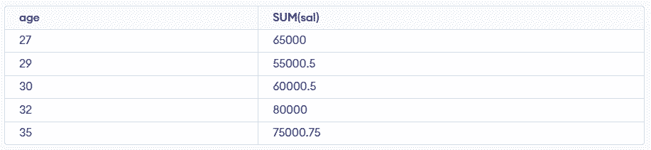
- Groups employees by age and sums their salaries.
- Returns only ages where total salary exceeds 50000.

Example 2: Filter by Average Salary
In this query, we group employees by age and display only those age groups where average salary is above 60,000.
SELECT age, AVG(sal) AS Average_Salary
FROM Employees
GROUP BY age
HAVING AVG(sal) > 60000;
Output:
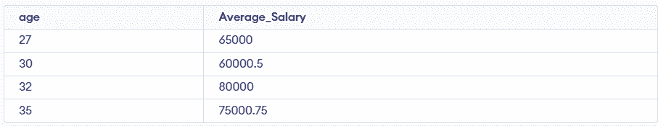
- Groups employees by age and calculates average salary.
- Filters only age groups with average salary above 60000.

SQL HAVING Clause:

The SQL HAVING clause filters the results of grouped data after using the GROUP BY clause. It is used with aggregate functions such as SUM(), COUNT(), or AVG() to display only those groups that meet specific conditions.
Example: First, we will create a demo SQL database and table, on which we will use the HAVING Clause command.
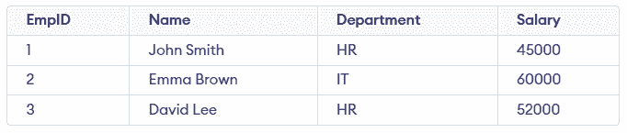
Query:
SELECT Department, COUNT(EmpID) AS Employee_Count
FROM Employees
GROUP BY Department
HAVING COUNT(EmpID) > 1;
Output:
Syntax:
SELECT column_name, AGGREGATE_FUNCTION(column_name)
FROM table_name
GROUP BY column_name
HAVING condition;
Note: When HAVING is used without GROUP BY, the entire table is treated as a single group. This works only with aggregate functions.

Examples of HAVING Clause
First, we create the Employee table and insert sample data to demonstrate the HAVING clause.
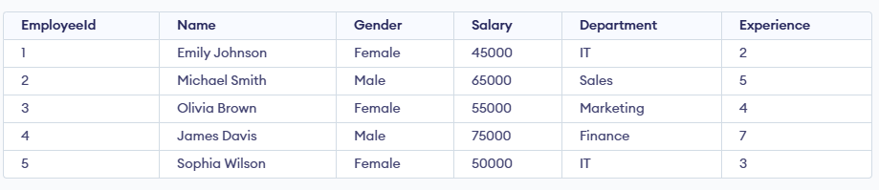Employee Table

Example 1: Filter Total Salary
In this example, we calculate the total salary of all employees and display it only if it meets the specified condition.
Query:
SELECT SUM(Salary) AS Total_Salary
FROM Employee
GROUP BY (SELECT 1)
HAVING SUM(Salary) >= 250000;
Output:
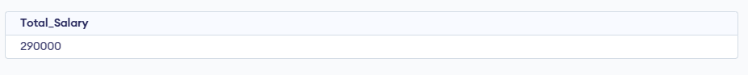
- SUM(Salary) adds up salaries of all employees.
- GROUP BY (SELECT 1) treats the entire table as one single group.
- HAVING SUM(Salary) >= 250000 filters the result and shows it only when the condition is met.
Note: GROUP BY (SELECT 1) is database-specific and may not work in all SQL databases. So alternatively, you can omit GROUP BY and use HAVING directly with aggregate functions.

Example 2: Filter Average Salary
In this example, we calculate the average salary of all employees and display it only if the average exceeds 55,000.
Query:
SELECT Department, AVG(Salary) AS AverageSalary
FROM Employee
GROUP BY Department
HAVING AVG(Salary) > 55000;
Output:
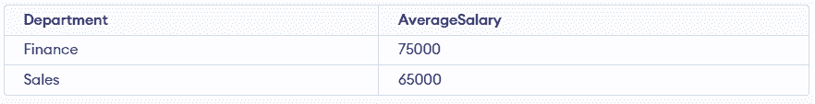
- GROUP BY Department calculates average salary per department.
- AVG(Salary) finds the department-wise average.
- HAVING AVG(Salary) > 55000 shows only departments whose average salary exceeds 55,000.

Example 3: Filter Maximum Salary
In this example, we find the highest salary among employees and display it only if it exceeds 70,000.
Query:
SELECT MAX(Salary) AS Max_Salary
FROM Employee
HAVING MAX(Salary) > 70000;
Output

Example 4: Filter Minimum Experience
In this example, we find the least experienced employee and display it only if their experience is less than 3 years.
Query:
SELECT MIN(Experience) AS Min_Experience
FROM Employee
HAVING MIN(Experience) < 3;
Output

Example 5: Multiple Conditions
In this example, we calculate both the total and average salary of employees and display the results only if the total salary is at least 250,000 and the average salary exceeds 55,000.
Query:
SELECT SUM(Salary) AS Total_Salary, AVG(Salary) AS Average_Salary
FROM Employee
HAVING SUM(Salary) >= 250000 AND AVG(Salary) > 55000;
Output:

SQL Distinct Clause:

The SQL DISTINCT clause is used to remove duplicate values from query results. It ensures that the output shows only unique records for the specified column(s).
Example: First, we will create a demo SQL database and table, on which we will use the Distinct Clause command.
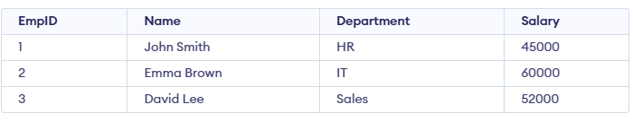
Query:
SELECT DISTINCT Department
FROM Employees;
Output:
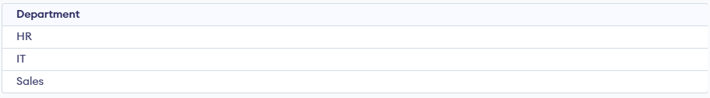
Syntax:
SELECT DISTINCT column1, column2
FROM table_name;
- column1, column2: Names of the fields of the table.
- Table_name: Table from where we want to fetch the records.
Note: If used on multiple columns, DISTINCT returns unique combinations of values across those columns.

Examples of DISTINCT in SQL
Let’s create a sample table and populate it with some duplicate entries. We will see some examples of using the DISTINCT keyword with a sample students table.
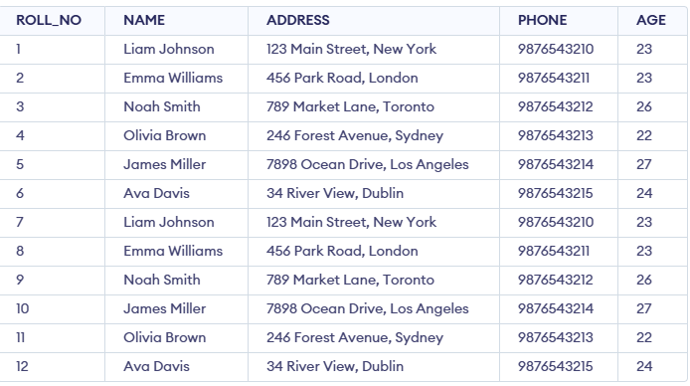

Example 1: Fetch Unique Names from the NAME Field
The query returns only unique names, eliminating the duplicate entries from the table.
Query:
SELECT DISTINCT NAME
FROM students;
Output:
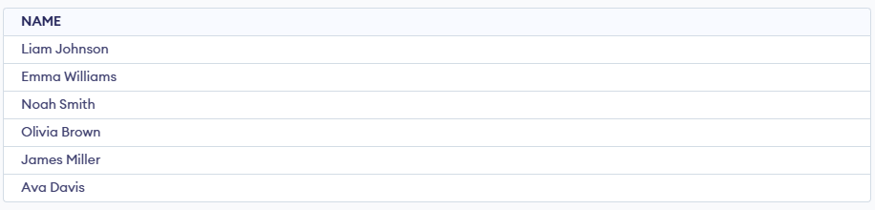

Example 2: Fetching Unique Combinations of Multiple Columns
This query retrieves distinct combinations of NAME and AGE, if two rows have the same name and age, only one of them will appear in the result set.
Query:
SELECT DISTINCT NAME, AGE
FROM students;
Output:
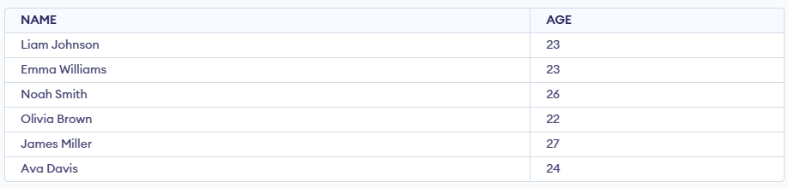

Example 3: Using DISTINCT with the ORDER BY Clause
We can combine the DISTINCT keyword with the ORDER BY clause to filter unique values while sorting the result set. This query retrieves the unique ages from the students table and sorts them in ascending order.
Query:
SELECT DISTINCT AGE
FROM students
ORDER BY AGE;
Output:
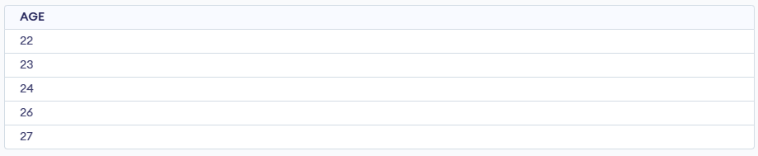

Example 4: Using DISTINCT with Aggregate Functions (e.g., COUNT())
Here, we will check the COUNT() function with a DISTINCT clause, which will give the total number of students by using the COUNT() function.
Query:
SELECT COUNT(DISTINCT ROLL_NO)
FROM Students ;
Output:

Example 5: DISTINCT with NULL Values
In SQL, the DISTINCT keyword treats all NULL values as the same, not as separate unique values. As a result, even if multiple rows contain NULL, DISTINCT will return NULL only once in the result set.
Query:
INSERT INTO students (ROLL_NO, NAME, ADDRESS, PHONE, AGE)
VALUES (13, 'John Doe', '123 Unknown Street', '9876543216', NULL),
(14, 'James Brown', '129 Unknown Street', '9876554317', NULL);

SELECT DISTINCT AGE
FROM students;
Output:
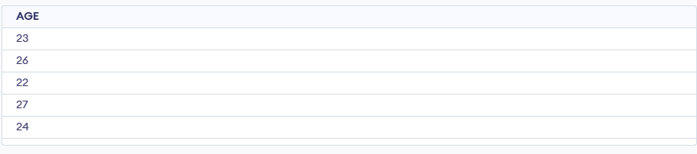
- Multiple rows with AGE = NULL are treated as the same value by DISTINCT.
- As a result, NULL appears only once in the query output.

SQL ORDER BY:

SQL ORDER BY is used to sort the result set of a query in either ascending (ASC) or descending (DESC) order. By default, ORDER BY sorts in ascending order. Sorting can be applied to one or more columns, which helps organize and analyze data effectively.
Example: First, we will create a demo SQL database and table, on which we will use the ORDER BY command.

Query:
SELECT EmpID, Name, Department, Salary
FROM Employees
ORDER BY
Salary DESC;
Output:
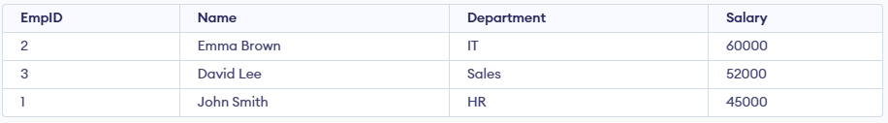
Syntax:
SELECT * FROM table_name ORDER BY column_name ASC | DESC;
- table_name: name of the table.
- column_name: name of the column according to which the data is needed to be arranged.
- ASC: to sort the data in ascending order.
- DESC: to sort the data in descending order.

Examples
We have created a Student table that stores student data including their roll_no, name, age, addess, and phone. Let's look at some examples of the SQL ORDER BY clause to understand it's working in SQL. We will use the following table in examples.
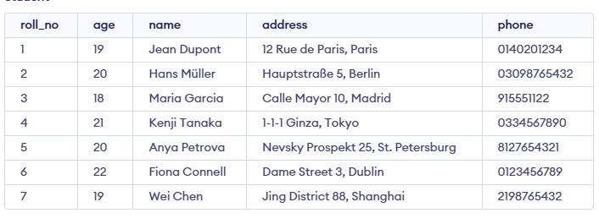
Now consider the above database table and find the results of different queries.

Example 1 : Sort by a Single Column
In this example, we will fetch all data from the table Student and sort the result in descending order according to the column ROLL_NO.
Query:
SELECT * FROM students ORDER BY ROLL_NO DESC;
Output:
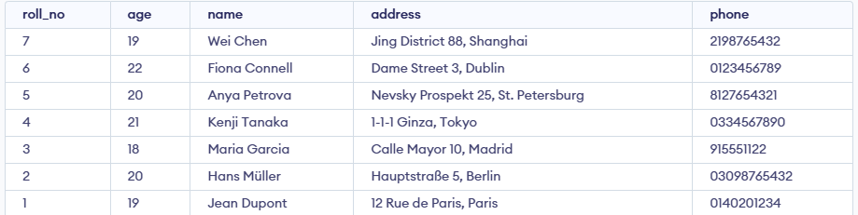
In the above example, if we want to sort in ascending order we have to use ASC in place of DESC.

Example 2 : Sort by Multiple Columns
In this example, we will fetch all data from the table Student and then sort the result in descending order first according to the column age and then in ascending order according to the column name.
To sort according to multiple columns, separate the names of columns by the (,) operator.
Query:
SELECT * FROM students ORDER BY age DESC , name ASC;
Output:
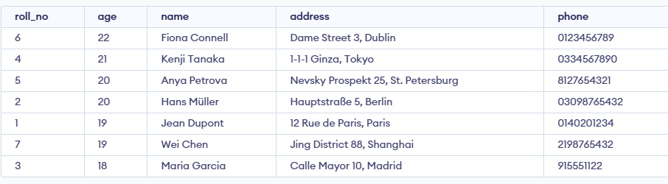
The result is first sorted by Age in descending order. For rows with the same Age, it’s further sorted by Name in ascending order.

Sorting By Column Number
Instead of using column names, you can sort results using the position of a column in the SELECT list. The number must be greater than 0 and not exceed the number of selected columns.
- Using column numbers in ORDER BY reduces query readability.
- Referring to columns by name is clearer and easier to understand.
- Changing column order in SELECT doesn’t affect ORDER BY when using names.
- Prefer column names over numbers for maintainable SQL code.
Syntax:
ORDER BY Column_Number asc/desc;

Example of Sorting By Column Number
Here we take an example to sort a database table according to column 1 i.e Roll Number. For this a query will be:
Query:
CREATE TABLE studentinfo
( Roll_no INT,
NAME VARCHAR(25),
Address VARCHAR(20),
CONTACTNO BIGINT NOT NULL,
Age INT );
INSERT INTO studentinfo
VALUES
(7, 'LUCAS', 'BERLIN', 4915123456789, 18),
(4, 'EMILIA', 'WARSAW', 481234567890, 18),
(1, 'HUGO', 'PARIS', 331234567890, 18),
(8, 'SOFIA', 'MADRID', 341612345678, 19),
(5, 'OLIVER', 'LONDON', 447912345678, 19),
(2, 'MATEO', 'ROME', 390612345678, 19),
(6, 'ISABELLA', 'LISBON', 351912345678, 20),
(3, 'ANNA', 'PRAGUE', 420777123456, 20);
SELECT Roll_no, Name, Address
FROM studentinfo
ORDER BY 1
Output:
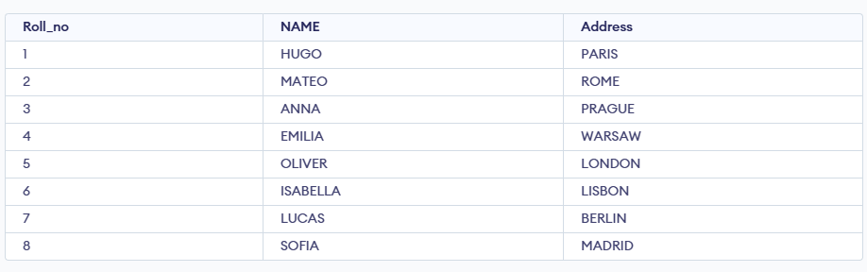
Explanation: ORDER BY 1 means sorting values according to first column in the SELECT statement.

MySQL LIMIT Clause:

MySQL consists of various clauses for performing efficient data retrieval, and the LIMIT clause is essential for controlling the number of rows returned in a query. By specifying a limit on the number of results, the LIMIT clause helps manage large datasets, optimize performance, and focus on relevant data. This article will explore the LIMIT clause, showing its usage in terms of examples.

MySQL LIMIT Clause:
The LIMIT clause in MySQL is used to specify the maximum number of rows returned by a query. It is particularly useful for managing large result sets and optimizing query performance. By setting a row limit, you can control the amount of data retrieved and efficiently paginate through results.
Syntax:
The syntax for using LIMIT Clause in MySQL is as follows:
SELECT column_name(s)
FROM table_name
LIMIT [offset,] row_count;
Parameters:
- offset (optional): The starting point from which rows are returned. If omitted, it defaults to 0.
- row_count: The maximum number of rows to return.

MySQL LIMIT Clause Example:
Let’s look at some examples of the LIMIT Clause in MySQL. Learning the LIMIT Clause with examples will help in understanding the concept better.
First, let’s create a table:

Demo MySQL Database:
CREATE TABLE employees (
employee_id INT,
name VARCHAR(50),
salary DECIMAL(10, 2)
);
INSERT INTO employees (employee_id, name, salary) VALUES
(1, 'Gaurav', 75000.00),
(2, 'Yuvraj', 82000.00),
(3, 'Shruti', 69000.00),
(4, 'Anjali', 90000.00),
(5, 'Vaishnavi', 85000.00),
(6, 'Gauri', 78000.00);
SELECT * FROM employees;
Output:
+-------------+-----------+----------+
| employee_id | name | salary |
+-------------+-----------+----------+
| 1 | Gaurav | 75000.00 |
| 2 | Yuvraj | 82000.00 |
| 3 | Shruti | 69000.00 |
| 4 | Anjali | 90000.00 |
| 5 | Vaishnavi | 85000.00 |
| 6 | Gauri | 78000.00 |
+-------------+-----------+----------+

Example 1: Retrieve the First 3 Records
In this example, we are using the LIMIT clause to fetch the first 3 records from the employees table. This query returns the earliest entries based on their order in the table.
SELECT * FROM employees
LIMIT 3;
Output:
+-------------+--------+----------+
| employee_id | name | salary |
+-------------+--------+----------+
| 1 | Gaurav | 75000.00 |
| 2 | Yuvraj | 82000.00 |
| 3 | Shruti | 69000.00 |
+-------------+--------+----------+

Example 2: Retrieve 3 Records Starting from the 2nd Record
In this example, we are using the LIMIT clause with an offset to skip the first record and return the next 3 records from the employees table. This allows us to paginate through the results by specifying a starting point.
SELECT * FROM employees
LIMIT 1, 3;
Output:
+-------------+--------+----------+
| employee_id | name | salary |
+-------------+--------+----------+
| 2 | Yuvraj | 82000.00 |
| 3 | Shruti | 69000.00 |
| 4 | Anjali | 90000.00 |
+-------------+--------+----------+

Example 3: Retrieve the Last 2 Records
In this example, we are using the LIMIT clause in combination with ORDER BY to fetch the last 2 records from the employees table. Sorting the results in descending order and limiting the output lets us obtain the most recent entries.
SELECT * FROM employees
ORDER BY employee_id DESC
LIMIT 2;
Output:
+-------------+-----------+----------+
| employee_id | name | salary |
+-------------+-----------+----------+
| 6 | Gauri | 78000.00 |
| 5 | Vaishnavi | 85000.00 |
+-------------+-----------+----------+

Conclusion
In conclusion, the LIMIT clause in MySQL is a useful clause for controlling the number of rows returned by a query. It enables efficient data management by allowing you to focus on a subset of records, optimize performance, and paginate results. Understanding and using LIMIT can significantly enhance your ability to handle large datasets effectively.

3. DML - Data Manipulation Language
DML commands are used to manipulate the data stored in database tables. With DML, you can insert new records, update existing ones, delete unwanted data or retrieve information.
Command | Description | Syntax
INSERT | Insert data into a table | INSERT INTO table_name (column1, column2, ...) VALUES (value1, value2, ...);
UPDATE | Update existing data within a table | UPDATE table_name SET column1 = value1, column2 = value2 WHERE condition;
DELETE | Delete records from a database table | DELETE FROM table_name WHERE condition;

SQL INSERT INTO Statement:

The SQL INSERT INTO statement is used to add new records into a table. It allows inserting data into all columns or specific ones, depending on the requirement.
- Can insert a single row or multiple rows at once.
- Supports inserting data directly or from another table using a subquery.

Working with INSERT INTO Statement
The INSERT INTO statement is used to add new records into a table, either by inserting full rows, selected columns, multiple rows at once, or copying data from another table.

1. Inserting Data into All Columns
This method is used when you want to insert data into all columns of a table without specifying column names. We simply provide the values for each column, in the same order that the columns are defined in the table.
Syntax:
INSERT INTO table_name
VALUES (value1, value2, value3, ...);
- table_name: name of the table where data will be inserted
- value1, value2... : values that correspond to each column in order.
Example: Let’s see how the INSERT INTO statement works with practical examples.
CREATE TABLE Student (
ROLL_NO INT PRIMARY KEY,
NAME VARCHAR(50),
ADDRESS VARCHAR(100),
PHONE VARCHAR(15),
AGE INT );
INSERT INTO Student (ROLL_NO, NAME, ADDRESS, PHONE, AGE)
VALUES (1, 'Liam', 'New York', 'xxxxxxxxxx', 18),
(2, 'Sophia', 'Berlin', 'xxxxxxxxxx', 18),
(3, 'Akira', 'Tokyo', 'xxxxxxxxxx', 20),
(4, 'Carlos', 'Tokyo', 'xxxxxxxxxx', 18);
Output:
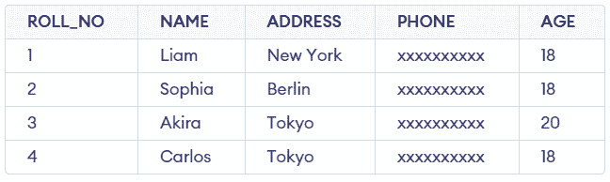
If we don’t want to specify the column names (and you’re inserting data into all columns), we can directly insert values in the order they appear in the table structure. Here's an example:
Query:
INSERT INTO Student
VALUES (5, 'Isabella', 'Rome', 'xxxxxxxxxx', 19);
Output:
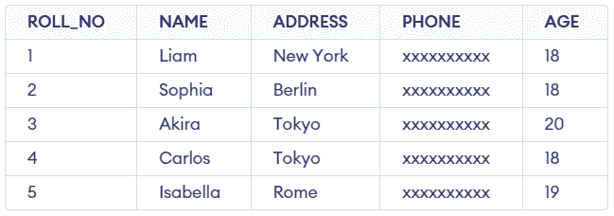

2. Inserting Data into Specific Columns
In some cases, you might want to insert data into only certain columns, leaving the others empty or with default values. In such cases, we can specify the column names explicitly.
Syntax:
INSERT INTO table_name (column1, column2, column3, ...)
VALUES (value1, value2, value3, ...);
- table_name: name of the table.
- column1, column2..: name of first column, second column.
- value1, value2, value3..: the values for each specified column of the new record.
Example: Let’s say we only want to insert the student's ID, name, and age into the Student table, and leave the address and phone number as NULL (the default value).
INSERT INTO Student (ROLL_NO, NAME, AGE)
VALUES (6, 'Hiroshi', 19);
Output:
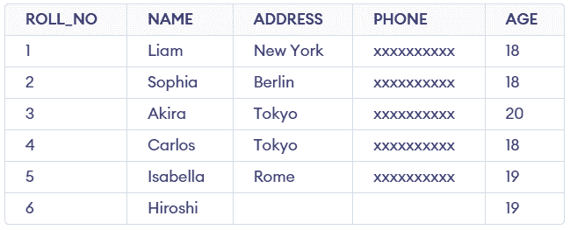
Note: Columns not included in INSERT statement are filled with default values (typically NULL).

3. Inserting Multiple Rows at Once
Instead of running multiple INSERT INTO commands, you can insert multiple rows into a table in a single query. This is more efficient and reduces the number of database operations.
Syntax:
INSERT INTO table_name (column1, column2, ...)
VALUES (value1, value2, ...), (value1, value2, ...), (value1, value2, ...);
Example: If we want to add multiple students to Student table in one go, query would look like this:
INSERT INTO Student (ROLL_NO, NAME, ADDRESS, PHONE, AGE)
VALUES
(7, 'Mateo Garcia', 'Madrid', 'xxxxxxxxxx', 15),
(8, 'Hana Suzuki', 'Osaka', 'xxxxxxxxxx', 18),
(9, 'Oliver Jensen', 'Copenhagen', 'xxxxxxxxxx', 17),
(10, 'Amelia Brown', 'London', 'xxxxxxxxxx', 17);
Output:
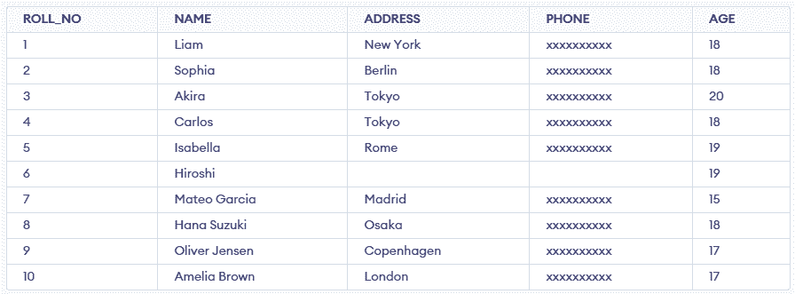
- Faster than multiple single inserts
- For very large data (>1000 rows), use bulk insert

4. Inserting Data from One Table into Another Table
We can also copy data from one table into another table using the INSERT INTO SELECT statement. This is very useful when we want to move or replicate data from one table to another without manually typing all the data.
Here, we are using below table OldStudent as another table and we will insert its rows into Student table using different methods.
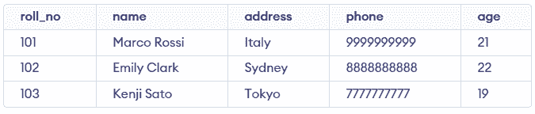OldStudent Table
[Method 1]: Insert All Columns from Another Table
Inserts every column from source table into destination table.
Syntax:
INSERT INTO target_table
SELECT * FROM source_table;
Example: If you want to copy all data from the OldStudent table into the Student table, use this query:
INSERT INTO Student
SELECT * FROM OldStudent;
Output:
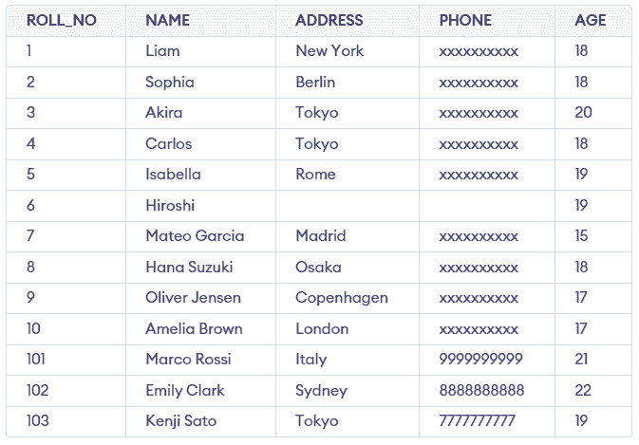
[Method 2]: Insert Specific Columns from Another Table
Allows inserting only selected columns from the source table.
Syntax:
INSERT INTO target_table (col1, col2, ...)
SELECT col1, col2, ...
FROM source_table;
Example: Let’s say we want to copy only the Name and Age columns from OldStudent into Student:
INSERT INTO Student (Name, Age)
SELECT Name, Age
FROM OldStudent;
Output:
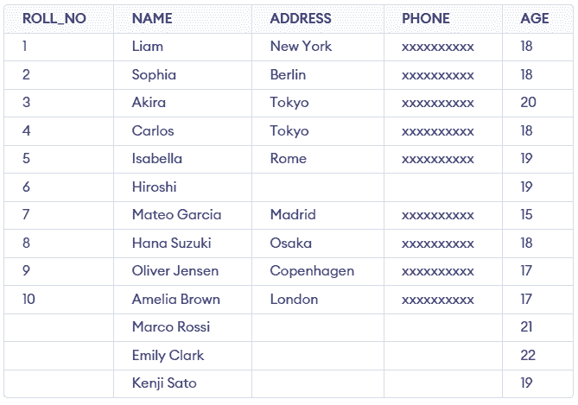
Note: Columns not included in INSERT statement (ROLL_NO, ADDRESS, PHONE) are automatically filled with NULL in target table.
[Method 3]: Insert Specific Rows Based on Condition
You can also insert specific rows based on a condition by using the WHERE clause with the SELECT statement.
Syntax:
INSERT INTO target_table
SELECT * FROM source_table
WHERE condition;
Example: If we want to copy only students older than 20 years from OldStudent to Student, we would write:
INSERT INTO Student
SELECT * FROM OldStudent
WHERE Age > 20;
Output:
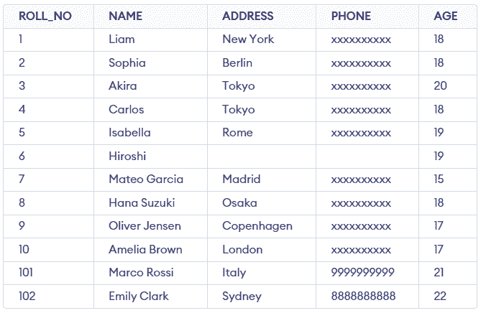

SQL UPDATE Statement
Last Updated : 9 Feb, 2026

The SQL UPDATE statement is used to modify existing data in a table by changing the values of one or more columns.
- The WHERE clause specifies which rows should be updated.
- Without WHERE, all rows in the table are modified.
Example: First, we will create a demo SQL database and table, on which we will use the UPDATE Statement command.
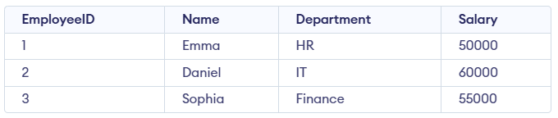
Query:
UPDATE Employees
SET Salary = 65000
WHERE Name = 'Daniel';
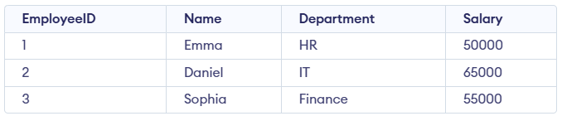
Syntax:
UPDATE table_name
SET column1 = value1, column2 = value2,...
WHERE condition;
- table_name: Name of the table you want to update.
- SET: The column(s) you want to update and their new values.
- WHERE: Filters the specific rows you want to update.
Note: The SET keyword assigns new values to columns, while the WHERE clause selects which rows to update. Without WHERE, all rows will be updated.

Working with the UPDATE Statement
Consider the Customer table shown below, which contains each customer’s unique ID, name, last name, phone number, and country. This table will be used to demonstrate how the SQL UPDATE statement works.
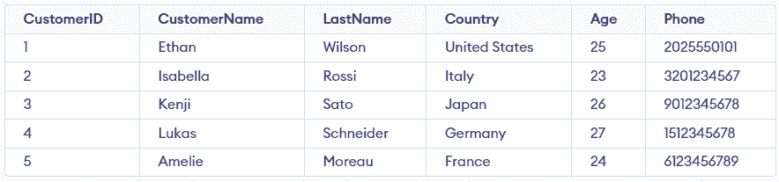Customer Table

Example 1: Update Single Column
We have a Customer table and we want to update the Age to 25 for the customer whose CustomerName is 'Isabella'.
Query:
UPDATE Customer
SET Age = 25
WHERE CustomerName = 'Isabella';
SELECT * FROM customer;
Output:
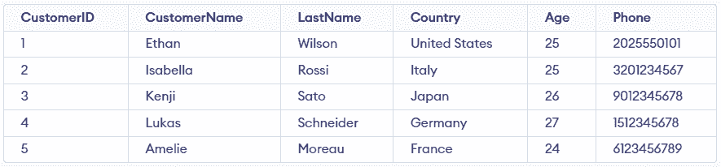
- The query updates the Age to 25 for the customer named 'Isabella'.
- It affects only the row where CustomerName = 'Isabella'.
- It is used to modify existing data in a specific record.

Example 2: Updating Multiple Columns
We need to update both the CustomerName and Country for a specific CustomerID.

Query:
UPDATE Customer
SET CustomerName = 'John',
Country = 'Spain'
WHERE CustomerID = 1;
Output:
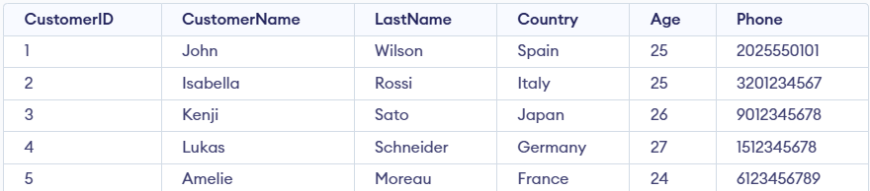
- The query targets the row where CustomerID = 1.
- It updates CustomerName to 'John' and Country to 'Spain'.
- Both columns are updated simultaneously in a single SQL statement.
Note: For updating multiple columns we have used comma(,) to separate the names and values of two columns.

Example 3: Omitting WHERE Clause in UPDATE Statement
If we accidentally omit the WHERE clause, all the rows in the table will be updated, which is a common mistake. Let’s update the CustomerName for every record in the table:
Query:
UPDATE Customer
SET CustomerName = 'Mike';
SELECT * FROM customer;
Output:
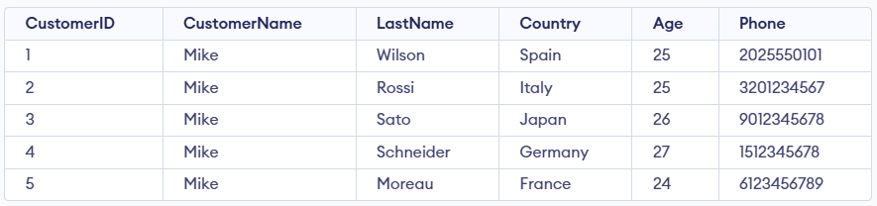
- Updates the CustomerName to 'Mike' for all rows in the Customer table.
- It affects every record because no WHERE clause is used.

SQL DELETE Statement
Last Updated : 13 Jan, 2026

The SQL DELETE statement is used to remove specific rows from a table while keeping the table structure intact. It is different from DROP, which deletes the entire table.
- It removes rows based on conditions.
- Retains table schema, constraints, and indexes.
- Can delete a single row or all rows.
Example: First, we create a demo SQL database and table, on which we will use the SQL DELETE command.
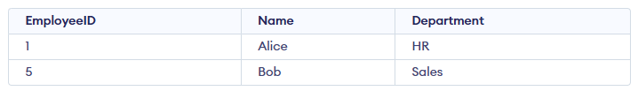
Query:
DELETE FROM Employees
WHERE EmployeeID = 5;
Output:
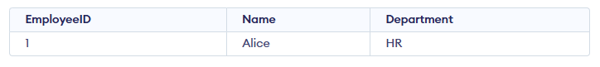
- This query deletes the row from the Employees table where the EmployeeID is 5.
- Only that specific record is removed; all other rows remain unchanged.
Syntax:
DELETE FROM table_name
WHERE some_condition;
- Some_condition: A condition used to filter the rows you want to delete.
- table_name: The name of the table from which you want to delete the rows.
Note: We can delete single or multiple records using the WHERE clause; if it’s omitted, all records in the table are removed.

Working with the DELETE Statement
Consider the Employee table in SQL, which stores employee details such as id, name, email, and department, as shown below.
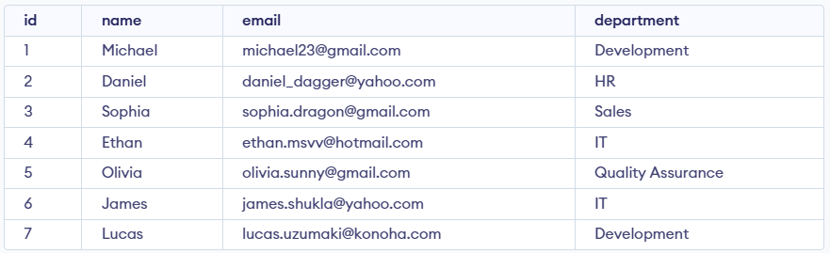Employees Table

Example 1: Deleting Single Record
We can use the DELETE statement with a condition to delete a specific row from a table. The WHERE clause ensures only the intended record is removed. We can delete the records named Ethan by using the below query:
Query:
DELETE FROM Employees
WHERE NAME = 'Ethan';
SELECT * FROM Employees;
Output:
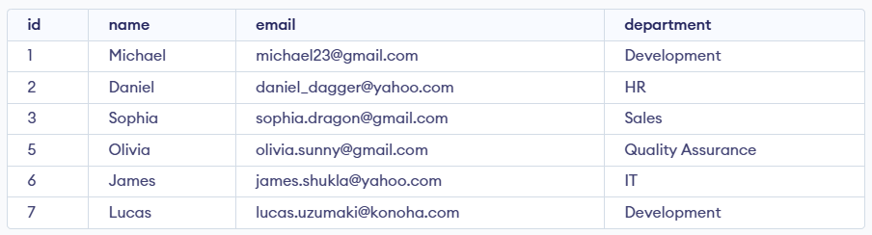

Example 2: Deleting Multiple Records
To delete multiple records, you can specify a condition that matches several rows. Let's delete the rows from the table Employees where the department is "Development". This will delete 2 rows (the first row and the seventh row).
Query:
DELETE FROM Employees
WHERE department = 'Development';
SELECT * FROM Employees;

Output
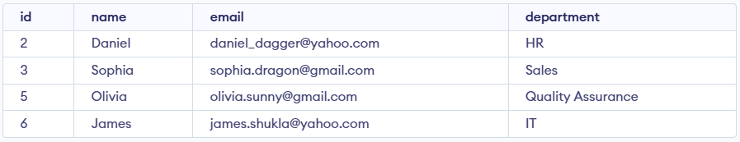

Example 3: Delete All Records from a Table
If we need to delete all records from the table, we can omit the WHERE clause, or alternatively use the DELETE statement with an asterisk (*) to denote all rows.
Query:
DELETE FROM Employees;
Output:
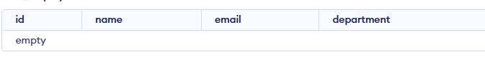
All of the records in the table will be deleted, there are no records left to display. The table Employees will become empty.

Rolling Back DELETE Operations
Since the DELETE statement is a DML operation, it can be rolled back when executed in a statement. If you accidentally delete records or need to repeat the process, you can use the ROLLBACK command.
Query:
BEGIN TRANSACTION;
DELETE FROM Employees;
WHERE department = 'Development';

-- If needed, you can rollback the deletion
ROLLBACK;
Explanation: The ROLLBACK command will undo the changes made by the DELETE statement, effectively restoring the records that were deleted during the transaction

4. DCL - Data Control Language
DCL (Data Control Language) includes commands such as GRANT and REVOKE which mainly deal with the rights, permissions and other controls of the database system. These commands are used to control access to data in the database by granting or revoking permissions.
Command | Description | Syntax
GRANT | Assigns new privileges to a user account, allowing access to specific database objects, actions or functions. | GRANT privilege_type [(column_list)] ON [object_type] object_name TO user [WITH GRANT OPTION];
REVOKE | Removes previously granted privileges from a user account, taking away their access to certain database objects or actions. | REVOKE [GRANT OPTION FOR] privilege_type [(column_list)] ON [object_type] object_name FROM user [CASCADE];

5. TCL - Transaction Control Language
Transactions group a set of tasks into a single execution unit. Each transaction begins with a specific task and ends when all the tasks in the group are successfully completed. If any of the tasks fail, transaction fails. Therefore, a transaction has only two results: success or failure.
Command | Description | Syntax
BEGIN TRANSACTION | Starts a new transaction | BEGIN TRANSACTION [transaction_name];
COMMIT | Saves all changes made during the transaction | COMMIT;
ROLLBACK | Undoes all changes made during the transaction | ROLLBACK;
SAVEPOINT | Creates a savepoint within the current transaction | SAVEPOINT savepoint_name;

Example:
BEGIN TRANSACTION;
UPDATE employees SET department = 'Marketing' WHERE department = 'Sales';
SAVEPOINT before_update;
UPDATE employees SET department = 'IT' WHERE department = 'HR';
ROLLBACK TO SAVEPOINT before_update;
COMMIT;

In this example, a transaction is started, changes are made and a savepoint is set. If needed, the transaction can be rolled back to the savepoint before being committed.

